STUDY ON THE POTENTIAL DEVELOPMENT OF INDUSTRIAL ECOSYSTEMS APPLICATIONS AND DIGITAL CONTENT IN INDONESIA

STUDI POTENSI PENGEMBANGAN EKOSISTEM INDUSTRI APLIKASI PERANGKAT LUNAK DAN KONTEN DIGITAL DI INDONESIA

Ahmad Budi Setiawan
Puslitbang APTIKA & IKP, Badan Litbang SDM. Kementerian Kominfo.
Jl. Medan Merdeka Barat No. 9 Jakarta 10110. Telp./Fax.: 021-3800418
e-mail: ahma003@kominfo.go.id

Abstract
The phenomenon of digitization has changed human civilization at a very massive level in various aspects of life. In line with the advancement of ICT, so have the development of innovation and the software and digital content industry. Competition in the software industry is starting to develop. The ability to increase the company's production is starting to show significant changes. Industry competition in the globalization process requires existing companies to be able to develop industrial capabilities with all industrial models and policies. The role of government is still an important factor in creating an environment in which the domestic telematics industry can gain a competitive advantage. This study aims to map the potential of the digital content and software application industry in Indonesia. This study was conducted qualitatively through literature studies. The output of this study produces a mapping of the potential for the software and digital content industry in Indonesia. The results of this study can support recommendations for policies related to the development of the software application industry and digital content in Indonesia.
Keywords : Potential Development, Industry, Software Applications, Digital Content

Abstrak
Fenomena digitalisasi telah merubah peradaban umat manusia dalam tingkat yang sangat masif di berbagai aspek kehidupan. Sejalan dengan kemajuan TIK, begitu pula dengan perkembangan inovasi dan industri Perangkat Lunak dan Konten digital. Persaingan industri perangkat lunak saat ini mulai berkembang. Kemampuan untuk meningkatkan produksi perusahaan mulai menunjukan perubahan yang signifikan. Persaingan industri dalam proses globalisasi mensyaratkan perusahaan-perusahaan yang ada untuk dapat mengembangkan kemampuan industri dengan segala model industri dan kebijakannya. Peranan pemerintah masih menjadi faktor penting dalam menciptakan lingkungan dimana industri telematika dalam negeri dapat memperoleh keunggulan kompetitif. Kajian ini bertujuan untuk melakukan pemetaan potensi industri konten digital dan aplikasi perangkat lunak di Indonesia. Kajian ini dilakukan secara kualitatif melalui studi literatur. Keluaran dari kajian ini menghasilkan pemetaan potensi industry perangkat lunak dan konten digital di Indonesia. Hasil kajian ini dapat mendukung rekomendasi bagi kebijakan terkait dengan pengembangan industri aplikasi perangkat lunak dan konten digital di Indonesia.
Kata Kunci: Potensi Pengembangan, Industri, Aplikasi Perangkat Lunak, Konten Digital

INTRODUCTION

Background
Along with the rapid development of information and communication technology, the phenomenon of digitalization has changed human civilization at a very massive level in various aspects of life. In this era, anyone who is not responsive to adopting technology will slowly be left behind with newer and more advanced technology. Massively, this of course affects business behavior and global economic conditions, so that the digital economy was born.
The digital economy is a new resource that Indonesia has. The development of the digital economy era rests on the birth and growth of entrepreneurs whose bases are talents, ideas and digital technology to produce innovation. These entrepreneurs are known as Digitalpreneurs. The innovations that are built are very complex and not easy to implement because there are no companies or innovators who are experts in all fields, for this reason, these innovations must be able to collaborate several different skills and knowledge.
In the future, economic players must cooperate with technology, especially digital technology. Factors that can support this development are the use of technology and improving the quality of Indonesia's Human Resources (HR). In fact, according to PWC data in February 2017, Indonesia is predicted to be ranked 5th in the world's largest economy by 2030 (PWC, 2017).
Based on data from the Directorate of Electronics and Telematics Industry, Ministry of Industry, currently only 20% of software industry business players are local industries, the rest are foreign industries. Even so, the potential of local software developers from year to year continues to increase. It is proven that the domestic software market opportunity reaches 110 million dollars per year (Warsito, 2015). The weak competitiveness of the local software industry has previously been mentioned because there is no standard that can be used as a process model for the maturity of the domestic software industry. Seeing the above phenomena and the fact that the potential for local software developers is increasing from year to year, encouraging the government to immediately make regulations and standards that can encourage the growth and development of the software and content industry in the country. The policies and standards used must have a methodology that has been tested in best practice which takes a long time to be able to find their own method that is most suitable to the conditions in the country (Wijaya, 2008).
The potential for the software market is huge and can reach US $ 600 million per year. Currently, many millennials develop software content personally and sell it to the Apple Store or Google Play Store (Ministry of Industry, 2017). With this potential, the Government is targeting investment in the telematics industry to reach a minimum of US $ 60 million per year. This target is enforced in accordance with the domestic component level scheme (TKDN) of smart phones established by the government. If it is not managed properly, the nation's great potential will not be able to enter the industrial world that requires engineering. What is currently owned by Indonesia is nothing more than potential and is waiting to be worked on further towards industry.
Based on the problems that have been described previously, the formulation of the problem that becomes the question in this study is how the potential for the development of the content industry and ICT applications based on innovation and creative industries to increase the contribution to the national economy?

Literatur Review
This study is related to literature related to the object of study. Literature that is relevant to the object of research is the policy and governance of software and content applications in order to plan a strategy for developing the software and content industry in Indonesia as a driver of the digital economy in Indonesia.

Definition and Industry Classification of Software Applications and Digital Content
Based on the Annex "Guide to measuring the information society" (2005), the OECD has defined the ICT group and also emphasizes the intersection between information technology, telecommunications and information content activities within a company or organization.
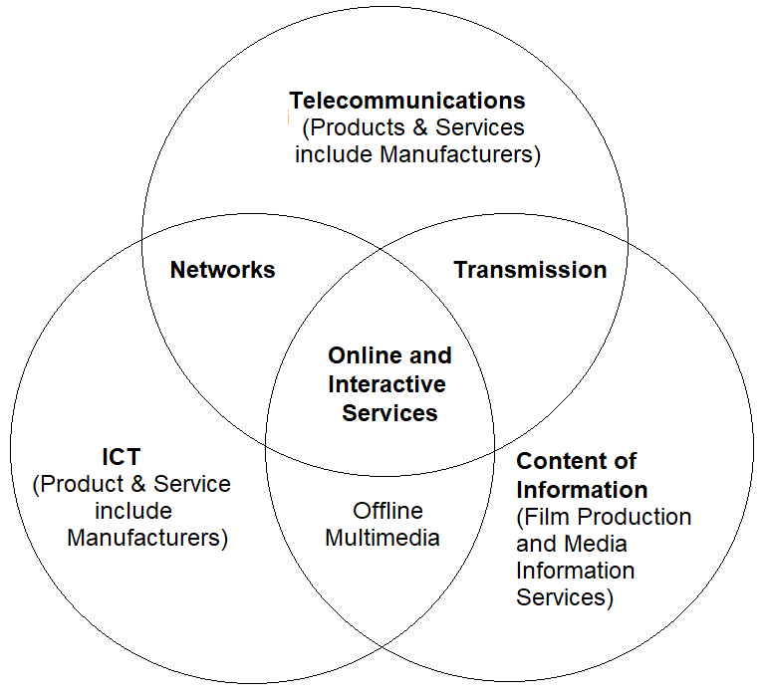

Figure 1. Group of ICT Activities
The content industry is then referred to as something different, although complementary to the ICT sector. The definition of ICT is: "those industries which facilitate, by electronic means, the processing, transmission and display of information". This definition explicitly does not include industries that produce information or what are then called the content industry. The content industry is divided into three types, among others:
- Multimedia Creator, namely digital content that combines sound, data, and video-based materials with the majority of application functions in the entertainment, social and friendship fields;
- E-Commerce Creator, namely digital content that also combines voice, data and video-based material or stands alone with most application functions in the trading, commercial and business fields; and
- Publishing Creator, which is digital content which also combines sound, data and video-based material or stands alone with the majority of application functions in the fields of information, news, and its derivatives.

Meanwhile, based on literature studies, the software industry is an industrial activity related to the development of information technology including computer services, data processing, database development, software development, system integration, system design and analysis, software architectural design, and infrastructure design. software and hardware, and portal design including maintenance.

ICT Sector Industries
The development of standards is an important element of the mandate of the Working Party on Indicators for the Information Society (WPIIS). The first paragraph of the terms of reference reads: Industry will ensure continuous improvement in terms of data collection methodologies at the international level for measuring supply and demand, information and communication technology (ICT). This will include developing and maintaining standards for measuring the ICT sector, ICT goods and services, e-business including e-commerce, IT security, digital content and ICT diffusion for organizations and individuals.
The first achievement of WPIIS in that role came in 1998 when delegates agreed on the definition of an ICT-based industrial sector. The combined sector of manufacturing and industrial services which covers the production, delivery or display of data and information electronically. In order to promote international comparability of statistics and accelerate compilation of relevant data, the definition is based on current industry standards, namely the International Standard Industrial Classification, Revision 3.1 (ISIC Rev. 3.1) on all economic activities.
In 1998, it was recognized that an activity-based definition should be complemented by a classification of ICT products. Mapping products for activities will enable more precise quantification of production production related to ICTs and value added and employment, both in the core ICT sector and in other sectors of the economy.
The sector definition is complemented by the definition of ICT goods in 2003 and the definition of ICT services in 2006.The first is based on the 2002 version of the harmonized system used for trade statistics and the latter on the latest version of the Product Classification Center - UN or United Nation Central Product Classification (UN CPC). Furthermore and related to this, the Organization for Economic Co-operation and Development (OECD) has provided a framework for the ICT sector and to support basic economic analysis. For example, some of the key indicators published in the OECD's Information Technology Outlook; Science, Technology and Industry Scoreboard; The measurement of the ICT sector industry and the impact of ICTs on the economy is based on this definition. Such definitions have also been used for national data releases and analytical studies of interest to policy analysts.
The main objective of the ICT sector review is to maintain the classification standards in a contemporary (current) manner and seek to preserve them. This is a special challenge, where goods and services related to the latest / modern ICT will quickly emerge and develop. In more detail, the OECD proposes an ICT sector based on the general characteristics of industries that have ICT products. The following figure illustrates this proposal.
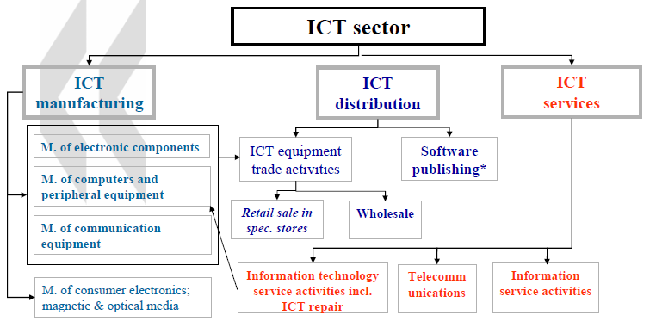

Figure 2. ICT Sector Industries
One important feature of the definition of the ICT sector proposed by the OECD is that it violates the traditional ISIC dichotomy between manufacturing and service activities. The activities of producing or distributing ICT products can be found in various aspects of the economy / industry. In addition, by identifying the key sectors whose main activity is the production or distribution of ICT products, this definition represents the first approach sequence of the ICT production sector.
With regards to digital content, the OECD defines that the sector is a group of economic activities / industry whose activities are mainly engaged in publishing and / or electronic distribution of content products. The value of these products to consumers does not lie in the quality / tangible form, but lies in the values ​​of information, education, culture or entertainment content. A content product is published through mass communication media in accordance with the message presented for the community / consumers. The chart in the following figure explains the relationship between digital content and the ICT sector in the information economy.

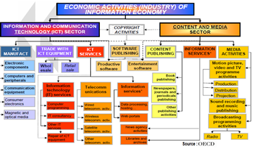

Figure 3. Industrial Activities in the Information Economy

Referring to the 2009 Indonesian Standard Business Field Classification (KBLI) issued by the Central Statistics Agency, based on the Regulation of the Head of the Central Statistics Agency No. 57 of 2009, the Software Industry and Digital Content Industry are included in the Information and Communication Group. Where the Software and Digital Content industry is included in the classification of Programming, Computer Consulting, Information Technology and Other Computer Services as well as the Production of Motion Picture, Video and Television Program Sub-categories.
Programming, Computer Consulting, Information Technology and Other Computer Services Sub-Activities include writing, modification, testing and supporting software activities to meet the needs of certain clients. Activities that are also included in this sub-category include; planning, designing, supplying and installing; computer system management and support services that integrate hardware, software and computer communication technology. Meanwhile, Moving Image, Video and Television Program Production Sub-category includes the production of moving images or animation including digital games (games), films, videos, television programs or television mobile advertisements.

Research Methodology
The stages of this research include research background, problem formulation, research objectives and problems. In this stage, literature studies are carried out to study various theories that are in accordance with the framework of research methodology in solving problems. The literature study used is related to case studies of information technology infrastructure planning in the research object environment, the software industry and digital content. Information technology infrastructure planning theories are taken from library materials, lecture materials, the internet, scientific journals and regulations, procedures, documents / references related to the industry.

Collection of Data and Information
The collection of data needed in this study uses several ways, namely:
- Interview method conducted to several parties related to the research;
- Focus Group Discussion (FGD) involving experts in the software application industry, digital content industry experts and representatives from the Directorate of Informatics Industry Empowerment as well as from the Ministry of Industry and the Ministry of Trade

RESULTS AND DISCUSSION
The development of communication and information technology in the last two decades has been very rapid, this is supported by the increasing spread and quality of telecommunications services, especially the Internet. The same thing also happens in Indonesia where telecommunication access has become a primary need that cannot be separated in everyday life.
Another challenge for a large country like Indonesia is the provision of infrastructure to support economic activity. The infrastructure itself has a very broad spectrum. One thing that must get the main attention is infrastructure that encourages connectivity between regions so that it can accelerate and expand Indonesia's economic development. Provision of infrastructure that encourages connectivity will reduce transportation costs and logistics costs so as to increase product competitiveness and accelerate economic movement. Included in this connectivity infrastructure is the development of transportation routes and information and communication technology (ICT), as well as all regulations and rules related to it.
The quality of human resources is still a challenge for Indonesia. Currently, about 50 percent of the workforce in Indonesia still has primary school education and only about 8 percent has a diploma / bachelor's degree. The quality of human resources is closely related to the quality of education, health facilities and access to basic infrastructure. In terms of Human Resources (HR), Indonesia is a country with the 4th largest population in the world. A large population with increasing purchasing power is a potential market, meanwhile, a large population with continuously improving quality of Human Resources (HR) is a potential for extraordinary competitiveness.
Indonesia is in a transition period in the structure of the productive age population. In the period 2020-2030, the decline in Indonesia's dependency index (which has been going on since 1970) will reach its lowest figure. An important implication of this condition is the increasing importance of providing employment so that the economy can make maximum use of the large portion of the population of productive age. More importantly, if the level of education in general is assumed to continue to improve, the productivity of the country's economy is actually in a premium condition, which will be very beneficial for the purposes of accelerating and expanding economic development.

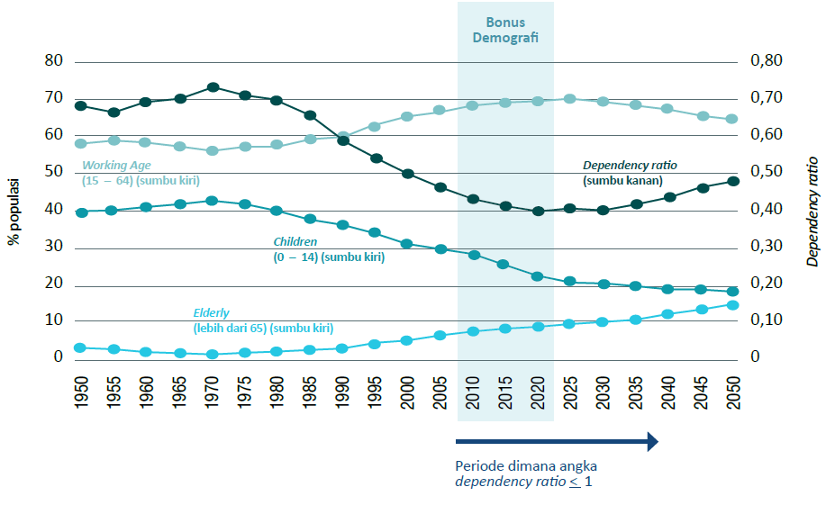

Figure 4. Age Demographics of the Indonesian Population

Indonesia is facing rapid urbanization. If in 2010 as much as 53 percent of Indonesia's population lived in urban areas, BPS predicts that by 2025 the population in urban areas will reach 65 percent. The direct implication that must be anticipated due to urbanization is an increase in movement patterns, changes in consumption patterns and production structures that have an impact on the labor structure, increased land use conflicts, and an increase in the need for reliable infrastructure support to support the distribution of goods and services. With all the potentials and challenges outlined above, Indonesia needs an acceleration of economic transformation so that the welfare of the entire community can be realized early.

Peta Kondisi Industri TIK di Indonesia
The development of communication and information technology in the last two decades has been very rapid, this is supported by the increasing spread and quality of telecommunications services, especially the Internet. The same thing also happens in Indonesia where telecommunication access has become a primary need that cannot be separated in everyday life. Its contribution to the country's economy also grew very significantly, in 2013 when our GDP only grew 5.78%, the telematics sector together with transportation could grow 10.19% and became the only sector that grew in double digits. Broadband penetration as a major ICT technology currently has a strong correlation with the Global Competitiveness Index. This relationship can be seen in Figure 5 below
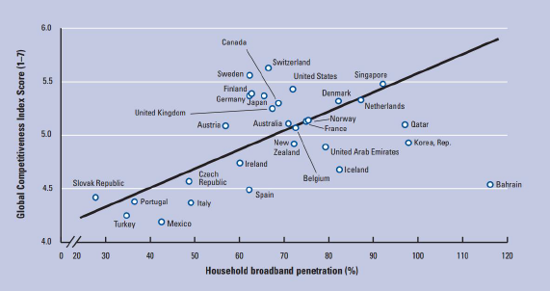

Figure 5. Broadband Penetration vs Global Competitiveness Index
(Source: World Economic Forum, 2010; ITU, 2010; Booz & Company analysis)

The level of telematics adoption in Indonesian society has also increased significantly. This is indicated by the number of cellphone users until October 2014 reaching more than 300 million numbers or penetration of 120% and exceeding the world average. The number of Indonesian internet users has reached 100 million people and is ranked 8th in the world with an average growth of 58% in the last 5 years. Indonesians are also very active in using internet-based applications, in our country's social media it is ranked 4th in the world for Facebook users and 5th for Twitter.
The Global Competitiveness Index is a comprehensive tool for measuring the microeconomic and macroeconomic foundations of a country. The World Economic Forum defines competitiveness as a set of institutions, policies, and factors that determine the level of productivity of a country. The level of productivity itself determines the rate of return on investment which is currently seen as the main driver of the growth rate. In other words, the more competitive a country's economy is, the greater the country's ability to support the sustainability of its economic growth.
The concept of competitiveness also relates to static and dynamic components. As previously stated, productivity also plays a central role in determining the rate of return on investment, which is actually a key factor in explaining a country's economic growth potential (Schwab, 2012).
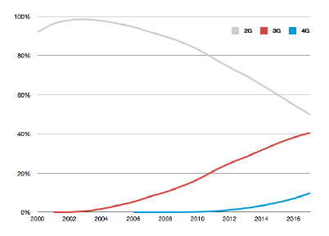

Figure 6. Global connection based on connection technology generation.
(Source: Wireless Intelligence, 2013)

Given the close relationship between broadband penetration and competitiveness, the topic of broadband is very strategic in national development. As is well known, one of the pillars of the Master Plan for the Acceleration of Indonesian Economic Development (MP3EI) is connectivity, one of which is ICT. In each and between MP3EI economic corridors, good ICT connectivity in the form of broadband networks must be built. Within this framework, replacement of copper cables with fiber-optic cables has been programmed.

Potential of Software Application and Digital Content Industry in Indonesia
From the available data sample, there are 33 companies or 31% of the total software industry companies located in West Java, followed by DKI Jakarta 26% (27 companies), and 12% in the Special Region of Yogyakarta (13 companies). Java Island still dominates the development of software companies, especially in DKI Jakarta. The existing software companies are located in capitals / big cities, where the economy is growing.
Meanwhile, there are 22 content industry companies, of which 42% of the total sample of companies are spread across DKI Jakarta, followed by West Java with 30% (15 companies) and 12% in East Java. A small number of others are in Yogyakarta, Central Java and Banten. Uniquely, from the sample data obtained, almost all of them are in Java Island. Java Island still dominates the development of digital content companies, especially in DKI Jakarta. The existing digital content companies are located in capitals / big cities, where the economy is growing. When viewed from the content category, there are 29 companies (58%) are games companies and 219 other companies (42%) are animation companies.
If classified according to the number of employees in the company, there are 89 software companies (35% of the total companies) which are classified as small companies with 0-20 employees, 10 companies are classified as medium-sized companies with 21-50 employees, and 4-6 companies. (4%) including large-scale companies. Meanwhile, the ratio of the number of IT employees to the total number of existing employees is around 32%.
Furthermore, software companies are noted to market their products the most domestically, namely 17% of the total sample of companies marketing their products at home and abroad. Only 2 companies that market overseas and the rest are not yet marketed (are startup companies). Some of these companies do business only through online. The listed companies' marketing target countries are Singapore, Taiwan, China and the Netherlands.
Meanwhile, from the data collected, 36% of the companies are classified as household or small companies with a total of 1-20 people. 20% of them are medium-scale companies with employees of 21-100 people, while the other 6% are large-scale companies with more than 100 employees. 19 other digital content companies that did not respond because the existing contact number could no longer be contacted or the contact person did not know the number of employees in the company.

Peta Industri Aplikasi Perangkat Lunak dan Konten Digital di Indonesia
The rapid development of information technology in Indonesia has been evident in the last two decades. This can be seen from the many uses of IT products for both personal and corporate / business use. Some of the related IT products are gadgets, software / applications, games, animation, and others. In fact, now IT has entered into the lifestyle of the majority of the capital's residents where people cannot be separated from IT-related matters in their daily lives. This has resulted in the emergence of a market that is wide open for the IT industry in Indonesia.
There have been many startups / start-ups in the information technology industry in recent years, particularly in the fields of software, games and digital content. According to the DKI Digital Creative Industry Map documentation, there are more than 150 companies in Jakarta, consisting of 120 software companies, 20 game companies and 28 animation companies. Of course, there are more companies engaged in IT in Indonesia. With the increasing number of startups / new companies, the government needs to control the development of the IT industry in order to maximize the existing potentials to improve the quality of the Indonesian economy.
Software industry companies develop / produce superior products for their users. The manufacture of these products is divided into two, namely making on request and making their own ideas then marketed. The products produced by these companies can be grouped by type of industry. The following are categories that define the types of industrial products a listed company produces:
- Banking
- Manufacturing
- Distribution / Retail
- Insurance
- Education
- Mining
- Plantation
- Cross Industry
- Travel
- Government / Public Sector
- Health
- Entertainment
- Outsourching
- Exercise
- Aviation
- Capital Intensive Industries
- Investment Management
- Creative Industries
- Property Industries
- Startup Industries
- Trading

Each company can have one or more industry categories according to each product. However, companies in the digital content industry are generally engaged in the Entertainment / Media industry. Each company can have one or more industry categories according to their respective software products. From the sample of company data, it is obtained that the software which is mostly developed by these companies is used for education (20%), entertainment (18%) and government (10%).
From the sample data collected, as many as 90% or 45 of the 50 companies are included in the Entertainment / Media industry category. The rest are only 1-3 companies engaged in other fields such as Education, Hospitaly, Retail, Engineering, and Manufacturing. Thus, based on existing data, 29 companies (58%) are games companies and 21 other companies (42%) are animation companies.
Of the 50 sample companies, 13 companies were not known for their marketing scope because these companies did not respond and we were unable to get the data through other information. Only 37 companies have successfully collected data. The number of companies that market their products both domestically and domestically and abroad has almost the same ratio. There are 18 companies whose marketing scope is domestic and foreign, as well as 16 companies with domestic marketing scope.

CLOSING
Conclusion
The digital content industry and software applications are a never-ending business because their main capital is creativity. Especially in today's era of mobile devices, more and more users are getting the most out of their smart phones or tablets. Currently, telecommunications is only a basic business for the use of technology. The sector that can be developed lies in software applications and digital content. The development of the digital content industry and software applications can also be a way out to determine the direction of the Indonesian technology industry.

Recommendation
Based on the discussion that has been carried out in this study, suggestions are given that can be given from the results of this study, among others;
- Increasing knowledge of human resources, in the form of easy access to knowledge such as books, training, tutors, and others.
- The government's support for digital content industry products and local local software applications is very important to be able to absorb the work of the nation's children so that it will trigger the high growth of content products
- Guiding the distribution of content products, helping to do marketing of Indonesian children's content works, and providing marketing distribution channels.
- Educate and facilitate the management of copyright and intellectual property rights, in order to protect the works of the nation's children.

REFERENCES

[1]. Dokumen Masterplan Percepatan dan Perluasan Pembangunan Ekonomi Indonesia 2011-2025. Jakarta: Kementrian Koordinator Bidang Perekonomian. 2011.
[2]. Kementerian Perindustrian, 2017, “Investasi Industri Telematika Ditargetkan US$ 60 Juta” https://kemenperin.go.id/artikel/17281/Investasi-Industri-Telematika-Ditargetkan-US&hx0024%3B&hx2212%3B60-Juta
[4]. Percepatan Pembangunan Kawasan Industri di Luar Pulau Jawa Melalui Pembangunan Infrastruktur Pendukung dalam Kerangka MP3EI, Direktur Jenderal Pengembangan Perwilayahn Industri, Jakarta, 12 Februari 2013.
[5]. Peta Industri Kreatif Digital DKI Jakarta dan Rekomendasi, MIKTI, 2013
[6]. Industry Clustering using the Value chain Approach, Merly M. Cruz, 12 March 2012.
[7]. Indonesia Broadband Plan, Sub Tim Kerja ICT, Tim Kerja Konektivitas KP3EI, Juni 2013.
[8]. Accelerating Indonesia’s Economic Transformation Through MP3EI, Eddy Satriya, KP3EI, November 2013.
[9]. Global Value chains in the Electronics Industry, Sturgeon and Kawakami, the World Bank, September 2010.
[10]. The Distribution of Value in the Mobile Phone Supply chain, Dedrick et. al, 2010
[11]. The Global Competitiveness Report 2012-2013, Klaus Schwab, World Economic Forum, 2012
[12]. “Strategi Pengembangan Industri Telematika di Indonesia”, Dokumen Kajian, Pusat Mikroelektronika Institut Teknologi Bandung. 19 Juni 2013
[14]. “Global Value chains in the Electronics Industry, Was the Crisis a Window of Opportunity for Developing Countries?", Timothy J. Sturgeon, Momoko Kawakami, The World Bank, September 2010.
[15]. "Kajian Membangun Kemitraan Bisnis Manufaktur Berbasis SMK", Studi Kasus Manufaktur Elektronika, Irman Idris, dan Tim, PUSAT MIKROELEKTRONIKA ITB, 2009.
[16]. “The Broadband-driven Transformation of Consumer Markets”, Dr. Martyn F. Roetter, http://www.intercomms.net/AUG03/content/adl.php, diakses 28 Desember 2013.
[17]. Simchi-Levi, D., Kaminsky, P., & Simchi-Levi, E. (2008). Designing and Managing the Supply chain. New York: McGraw-Hill.
[18]. Scanion, Robert, Aligning Product and Supply chain Strategies in the Mobile Phone Industry, MIT, 2009.

